NETWORK SECURITY, MAINTENANCE AND TROUBLESHOOTING PROCESS

NETWORK THREATS AND MITIGATION & PHYSICAL SECURITY AND RISK
TASK1: Create a table listing 5 common network threats (such as phishing, DDoS, man-in-the-middle, malware, and password attacks), and for each, write one real-world example from an app or service you use (like WhatsApp, Instagram, or Paytm).
Network Threat | Description | Real-World Example
Phishing | Fake emails or websites steal user information. | Fake Instagram login page asking for username and password.
DDoS Attack | Many devices flood a server with traffic to make it unavailable. | A gaming website becomes slow because of a DDoS attack.
Man-in-the-Middle (MITM) | An attacker secretly intercepts communication between two devices. | Using free public Wi-Fi to access Paytm without protection.
Malware | Harmful software that damages or steals data. | Downloading a fake WhatsApp APK that installs a virus.
Password Attack | Trying many passwords until the correct one is found. | Someone repeatedly tries to guess an Instagram password.

TASK2: Simulate a brute-force attack scenario by writing a simple Python script that tries to guess a 4-digit PIN code by checking all possible combinations against a preset value.<br><br><em><strong>Constraint:</strong> The script should print the number of attempts it took to guess the correct PIN.</em>
- Open VS Code or Python IDLE.
- Create a new file named: bruteforce.py
- Copy and paste the code below.
- Save the file.
- Click Run.
- Observe how many attempts it takes to guess the PIN.
CODE:
correct_pin = "2580"
attempts = 0

for pin in range(10000):
guess = str(pin).zfill(4)
attempts += 1

if guess == correct_pin:
print("PIN Found:", guess)
print("Attempts:", attempts)
break
OUTPUT:
PIN Found: 2580
Attempts: 2581
TASK3: List 4 physical security risks that could affect a server room hosting a popular app like Zomato or BookMyShow, and suggest one mitigation step for each risk.
Risk | Mitigation
Unauthorized Entry | Install biometric or key card access.
Fire | Install fire extinguishers and smoke detectors.
Theft | Install CCTV cameras and lock server racks.
Power Failure | Use a UPS and power backup system.

TASK4: Draw a simple floor plan (hand-drawn or digital) of a small office and mark at least 3 physical security measures you would implement to protect network equipment (such as CCTV, biometric access, or cable locks).
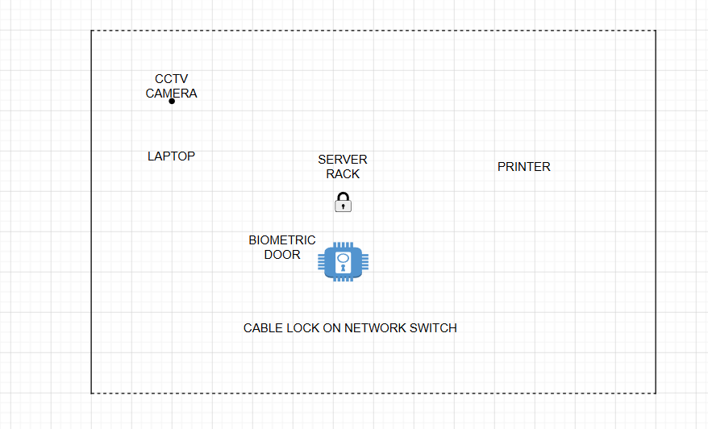
SECURITY MEASURES :
- CCTV Camera
- Biometric Door Access
- Cable Lock on Network Equipment

TASK5: Use ChatGPT or a similar AI tool to generate a checklist of 7 actions a network admin should take to mitigate risks from both network threats and physical security breaches, then review and edit the checklist to make it specific for a college computer lab environment.
NETWORK SECURITY CHECKLIST FOR A COLLEGE COMPUTER LAB:
- Install and regularly update antivirus software on all computers.
- Use strong passwords for student and administrator accounts.
- Enable Windows Firewall on every computer.
- Restrict access to the server room using locks or biometric access.
- Install CCTV cameras to monitor the computer lab.
- Regularly update the operating system and software.
- Take regular backups of important files and student records.

